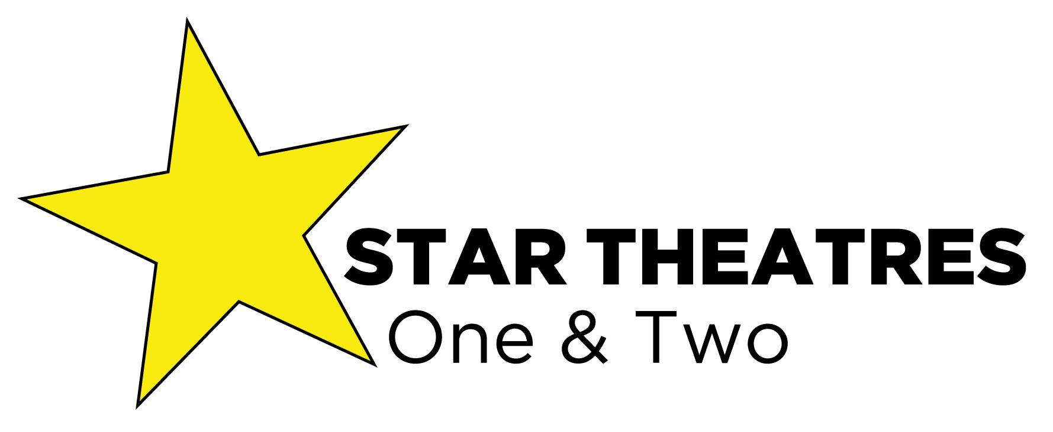
ABN 14 007 964 132
Hi, Theatre Hirer,
The below information is necessary so we can generate a contract for the hire of Star Theatres (Theatre One or Theatre Two).
This document is not the Contract.

When the contract is generated we will return via email, then please sign and return via email (an electronic signature is acceptable).

We can assist you to book tickets for your shows.
We have detailed plans for numbered seating through Try Booking and it assists us as we are the ones getting the phone enquiries, and assisted booking on line.

You can view the seating plans and other options at https://www.startheatres.com.au/hire.html

Details and costs for all services are on page. 3 and 4

Many Thanks,
Malcolm Harslett
Venue Manager

Please complete the booking form on Page 2 and return as a
Word Document. via email

This is the Booking Application Form for either theatre.

Which Theatre do you require?
Theatre One. Theatre Two. Please delete the one you are not booking.

Contact name:
Contact Phones (Mobile) (Land line)
Email:
Name of Company:
Postal Address:
ABN:
Performance name of company: (Name of show)
Payments made by bank transfer require the provided invoice number to be quoted in the description box.
Your Bank account name..................
Your BSB ..... and Account number......... for ticket reimbursement.

Hire Dates:

What seating plan would you like to use (full seating/cabaret/other)?
Bump in Time: Rehearsal Time:
Show Time: Interval time: Completion of show:
Expected bump-out finish time:
Duration of 1st Half: Interval: Duration of 2nd Half:
Number of Cast:
How do you plan to book tickets?
Do you wish to use the Star Theatre Booking site: *See Below
Please write a brief synopsis of production:

Please list props and set pieces you will be bringing into the Theatre:
Do you require any sound equipment? e.g. Number of mics?
Do you require the production to be Videoed for archival purposes?*Do you require a 2 camera video shoot for sale?*
Please note
Star Theatres is a 2 venue complex and quite often both theatres are working at the same time, therefore it is very important for us to understand your start, interval and finish times, so we can co- ordinate together as both theatres share a common foyer.

Name of your Front of House representative/manager (or ticket seller):
If you do not provide a FOH person to remain in the foyer to represent your show for the entire time of the performance, you will be charged a fee for a theatre Manager.

If you have any requirements that involve the foyer please note them here.

.................................................................................................................................................

Star Theatre One.
A space with endless possibilities.

Conventional Proscenium Arch Theatre with up to 356 theatre seats.
141 seats are on the flat (stalls) with171 on raised step seating (bleachers)
- Stage width 12,200mm (includes 1600mm wing width either side)
- Stage depth 8000mm
- Proscenium arch opening 7260mm x 2960mm
- Height of stage 770mm
- Height to borders 3600mm

OPTIONAL SEATING ARRANGEMENTS:
- Full theatre seating: 356 seats
Maximum amount of seats the theatre can hold.
- Full theatre seating (with a centre aisle): 335 seats
Our recommended regular seating plan, with an aisle on the lower seating.
- Half cabaret: 295 seats
Tabled seating on the flat floor, and regular seating in the raised section. Set up and pull down fee $400.00 + GST.
- Open Floor (using lower stage): 209 seats
The chairs are removed from the flat floor to create an extra lower stage.
- Other arrangements are possible if you contact us in advance.
- The Foyer
The foyer has an old world charm with its golden pillars and red carpet. It includes a licensed bar that links both theatres in comfortable surroundings.
Dressing Rooms
At the rear of the stage there are two dressing rooms that house up to 20 performers and a small props area. Other dressing space connected via Theatre 2 is available, for an additional fee of $33.00 a day (if available).
Basic Hire Charge
Daily Hire $1350.00 + GST
2 day hire $2190.00 + GST Consecutive Days
3 day hire $2730.00 + GST Consecutive Days
4 day hire $3120.00 + GST Consecutive Days
5 day hire $3410.00 + GST Consecutive Days
6 day hire $3700.00 + GST Consecutive Days
7 day Hire $4000.00 + GST Consecutive Days
Additional Charges
- House technician and stage crew Cost $55.00 per Hour +GST. (minimum 3 hour call) After 8 hours the Technician will be charged $110.00 per hour +GST.
- FOH management (if not provided by the hirer) $45.00+GST per hr
- Energy as per meter reading + GST
- Cleaning $45.00+ GST per hour (2 hour minimum)
- Lamp replacement $30.00 + GST per day
- Hire of any equipment, e.g. extra microphones, hazer, fog, or smoke machines
Free with hire: 1 wireless microphone (handheld or headset)
Star Theatres Two

A Boutique Proscenium Arch Theatre with 72 Seats.
- Raised 5m x 6m stage with 1.8m wings.
- Single 15 person dressing room.
- Cyclorama or black curtain at rear of stage.
- Fully functional lighting rig with conventional and intelligent lights.
- PA with foldback and multiple options for microphones and instrument input.
Seating
Theatre Two has 72 seats. 36 on the floor and 36 raised.
The Foyer
The foyer is styled in traditional “old world” theatre red and gold. Drinks and snacks can be purchased at the bar and brought into the venue, and this is where the male, female, and disabled toilets are located.
Dressing Rooms
At the rear of the stage, accessible by either side, is a single dressing room for up to 15 people. Other dressing room space, in the rear dance studio, is available for an additional $30 + GST a day.
Basic Hire Charge
Daily Hire $470.00 + GST
2 Day Hire $760.00 + GST For consecutive days
3 Day Hire $1060.00 + GST For consecutive days
4 Day Hire $1300.00 + GST For consecutive days
5 Day Hire $1470.00 + GST For consecutive days
Weekly Hire $1500.00+GST For consecutive days
Additional Charges
- House technician and stage crew Cost $55.00 per Hour +GST. (minimum 3 hour call) After 8 hours the Technician will be charged $110.00 per hour +GST.
- FOH management (if not provided by the hirer) $45.00+GST per hr
- Energy as per meter reading + GST
- Cleaning $45.00 + GST per hour (1 hour Minimum)
- Lamp replacement $30.00 + GST per day
- Hire of any equipment, e.g. extra microphones, hazer, fog, or smoke machine
Free with hire: 1 wireless microphone (handheld or headset.).

Star Theatres Studio

The Studio is approx. 7 metres square and has a sprung composite wooden floor and a mirrored wall. There are also sound system facilities, and air conditioning.
Basic Hire Charge
$30.00 per hr or $100.00 per day.
Minimum Staff Requirements
- An appointed Star Theatres technician must be at all bump ins and outs, rehearsals, and performances, and will be available to provide a variety of services.

- All companies must provide a front of house manager, either a ticket seller or door person, who will remain in the foyer during the performance representing the company. If unable, Star Theatre will appoint one at the hirer’s cost (minimum charge of $50.00).
…………………………………………………………………………………………………………....
Filming of Performances
- Single unmanned camera wide shot (as the audience would see the show) $200.00
- A manned single camera shoot for close ups and wide shots $400.00
- 2 camera shoot with wide shot and close-ups, without editing $500.00
- Editing of a 2 camera shoot varies depending on length of $300.00+ (this is in addition to the filming cost)
…………………………………………………………………………………………………
Rehearsal Space Pricing
A space in the building can be hired as a rehearsal space. When the building is used as a rehearsal space, no technical equipment can be used. However, portable sound systems are supplied upon request.
- $30/hr + GST
- $100/day + GST
…………………………………………………………………………………………………
Star Theatres Tickets
- $50.00 for initial setup + GST
- $0.50 + GST for every ticket sold, which covers the costs for phone and customer assist bookings.
- Please be aware as the ticket purchaser is the end user, they will be paying GST on your ticket, and more importantly you need to factor that in. If you want to receive $25.00 you will need to sell for $27.50 approx. The government will get the $2.50 and you will receive $25.00 less the credit card fees,
- TryBooking add a 50 cent fee per ticket, plus deduct credit card charges 2.05% processing fee– which may vary depending on what type of credit card the client uses.
- Booking plans are set up with various theatre configurations so patrons can select their seats, essential for advanced bookings. Cabaret table seating is also available in Theatre One in various configurations.
- Please provide us with
  - Full Ticket price (which includes GST)...........................
  - Child ticket price (which includes GST)..........................
  - Student/Pensioner/Disabled etc(which includes GST)....
  - Complementary/house seats.........................................
  - Or any other ticket fee applicable.

There are 2 ways you can book the theatres

Option 1
Star Theatres ticketing setup, and phone calls.
Theatre Deposit of $700 (theatre 1) and $300 (Theatre 2) + GST
Star Theatres will process and handle the total value of ticket sales, less Credit card and Processing fees and GST. GST is paid by Star Theatres on behalf of your show. The remaining ticket income is credited to you account. Please provide your BSB and Account information on the above form.

Option 2
A Theatre Deposit of the total value of X days hire e.g. $3500 + GST + an estimation of the other on costs (energy, staff wages etc). If a hirer doesn’t use the amount charged in the exit account a refund will be forthcoming into the designated account.
Ticketing set up and credit card processing fees, GST and administration of the ticketing process will be handled by the Venue Hirer {You}.

